EXPT NO:02 | EDA – DATA CLEANING

AIM:

To perform Exploratory Data Analysis (EDA) and data cleaning on the AI Impact on Jobs dataset to identify employment and AI-related patterns, handle missing values, remove duplicate records, detect inconsistencies and outliers, and prepare the dataset for Machine Learning.

PROCEDURE:

- Import the required Python libraries such as Pandas, NumPy, Matplotlib, and Seaborn.
- Load the AI Impact on Jobs 2030 dataset using Pandas.
- Display the first few records and check the dataset shape.
- Examine the data types and dataset information.
- Check for missing or null values.
- Handle missing values using suitable methods.
- Identify and remove duplicate records.
- Check for incorrect or inconsistent values in categorical and numerical columns.
- Detect possible outliers using statistical methods and visualization.
- Perform statistical analysis using the describe() function.
- Visualize important features such as AI Replacement Risk, Automation Level, and Years of Experience using graphs and charts.
- Analyze correlations between numerical features using a heatmap.
- Examine the distribution of the target variable AI Replacement Risk.
- Save the cleaned dataset for further analysis and Machine Learning.

CODE:
import pandas as pd
import numpy as np
import matplotlib.pyplot as plt
import seaborn as sns

df = pd.read_csv("AI_Impact_on_Jobs_2030.csv")

print("First 5 Records")
print(df.head())

print("\nDataset Shape")
print(df.shape)

print("\nDataset Information")
df.info()

print("\nMissing Values")
print(df.isnull().sum())

print("\nDuplicate Records")
print(df.duplicated().sum())

df = df.drop_duplicates().dropna()

print("\nStatistical Summary")
print(df.describe(include="all"))

plt.figure(figsize=(7,5))
sns.histplot(df["AI_Replacement_Risk"], bins=20, kde=True)
plt.title("AI Replacement Risk Distribution")
plt.xlabel("AI Replacement Risk")
plt.ylabel("Number of Jobs")
plt.show()

plt.figure(figsize=(7,5))
sns.boxplot(x="Automation_Level", y="AI_Replacement_Risk", data=df)
plt.title("Automation Level vs AI Replacement Risk")
plt.xlabel("Automation Level")
plt.ylabel("AI Replacement Risk")
plt.show()

plt.figure(figsize=(7,5))
plt.scatter(df["Years_Experience"], df["AI_Replacement_Risk"])
plt.title("Years of Experience vs AI Replacement Risk")
plt.xlabel("Years of Experience")
plt.ylabel("AI Replacement Risk")
plt.show()

numeric_data = df.select_dtypes(include=np.number)

plt.figure(figsize=(10,7))
sns.heatmap(numeric_data.corr(), annot=True, cmap="coolwarm", fmt=".2f")
plt.title("Correlation Heatmap")
plt.show()

df.to_excel("Cleaned_AI_Impact_on_Jobs_2030.xlsx", index=False)

print("\nCleaned dataset exported successfully!")

OUTPUT:

First 5 Records
Employee_ID Job_Title Industry Country Education_Level \
0 AIJ-100000 Data Engineer Healthcare Japan PhD
1 AIJ-100001 Healthcare Analyst Retail UK Bachelor
2 AIJ-100002 HR Specialist Education Canada High School
3 AIJ-100003 Cybersecurity Analyst Government UK Bachelor
4 AIJ-100004 Healthcare Analyst Education UAE PhD

Years_Experience AI_Replacement_Risk Future_Demand_Score \
0 1 0.25 0.78
1 24 0.73 0.33
2 21 0.80 0.69
3 5 0.29 0.94
4 20 0.11 0.92

Remote_Work_Possibility Average_Salary_USD \
0 Yes 207392
1 No 140785
2 Yes 124800
3 No 199878
4 No 178682

Required_Skills Automation_Level \
0 Python, Communication, Deep Learning Low
1 Deep Learning, Azure, Communication, TensorFlo... Low
2 Kubernetes, Cloud Computing, TensorFlow, SQL, ... Medium
3 Excel, Kubernetes, Prompt Engineering, Leadership Medium
4 SQL, Leadership, TensorFlow, Cybersecurity Low

Job_Growth_2030 Work_Hours_Per_Week Company_Size AI_Tool_Usage \
0 3 37 Enterprise High
1 -5 42 Startup Moderate
2 -5 57 Startup Low
3 7 59 Enterprise High
4 6 34 Startup High

Performance_Score Upskilling_Needed Job_Satisfaction Hiring_Trend_2026
0 2.08 Yes 3.86 Growing
1 4.54 No 4.23 Growing
2 3.14 No 3.54 Stable
3 3.67 No 4.37 Declining
4 3.68 No 3.99 Stable

Dataset Shape
(3000, 20)

Dataset Information
<class 'pandas.core.frame.DataFrame'>
RangeIndex: 3000 entries, 0 to 2999
Data columns (total 20 columns):
# Column Non-Null Count Dtype
--- ------ -------------- -----
0 Employee_ID 3000 non-null object
1 Job_Title 3000 non-null object
2 Industry 3000 non-null object
3 Country 3000 non-null object
4 Education_Level 3000 non-null object
5 Years_Experience 3000 non-null int64
6 AI_Replacement_Risk 3000 non-null float64
7 Future_Demand_Score 3000 non-null float64
8 Remote_Work_Possibility 3000 non-null object
9 Average_Salary_USD 3000 non-null int64
10 Required_Skills 3000 non-null object
11 Automation_Level 3000 non-null object
12 Job_Growth_2030 3000 non-null int64
13 Work_Hours_Per_Week 3000 non-null int64
14 Company_Size 3000 non-null object
15 AI_Tool_Usage 3000 non-null object
16 Performance_Score 3000 non-null float64
17 Upskilling_Needed 3000 non-null object
18 Job_Satisfaction 3000 non-null float64
19 Hiring_Trend_2026 3000 non-null object
dtypes: float64(4), int64(4), object(12)
memory usage: 468.9+ KB

Missing Values
Employee_ID 0
Job_Title 0
Industry 0
Country 0
Education_Level 0
Years_Experience 0
AI_Replacement_Risk 0
Future_Demand_Score 0
Remote_Work_Possibility 0
Average_Salary_USD 0
Required_Skills 0
Automation_Level 0
Job_Growth_2030 0
Work_Hours_Per_Week 0
Company_Size 0
AI_Tool_Usage 0
Performance_Score 0
Upskilling_Needed 0
Job_Satisfaction 0
Hiring_Trend_2026 0
dtype: int64

Duplicate Records
0

Statistical Summary
Employee_ID Job_Title Industry Country Education_Level \
count 3000 3000 3000 3000 3000
unique 3000 20 10 10 4
top AIJ-102999 Software Developer Energy UAE Bachelor
freq 1 164 335 347 782
mean NaN NaN NaN NaN NaN
std NaN NaN NaN NaN NaN
min NaN NaN NaN NaN NaN
25% NaN NaN NaN NaN NaN
50% NaN NaN NaN NaN NaN
75% NaN NaN NaN NaN NaN
max NaN NaN NaN NaN NaN

Years_Experience AI_Replacement_Risk Future_Demand_Score \
count 3000.000000 3000.000000 3000.000000
unique NaN NaN NaN
top NaN NaN NaN
freq NaN NaN NaN
mean 12.383000 0.502910 0.601203
std 7.528958 0.261293 0.226674
min 0.000000 0.050000 0.200000
25% 6.000000 0.280000 0.420000
50% 12.000000 0.500000 0.600000
75% 19.000000 0.730000 0.800000
max 25.000000 0.950000 0.990000

Remote_Work_Possibility Average_Salary_USD \
count 3000 3000.000000
unique 3 NaN
top Hybrid NaN
freq 1011 NaN
mean NaN 126641.746667
std NaN 55405.053057
min NaN 30221.000000
25% NaN 77262.000000
50% NaN 127660.500000
75% NaN 174811.750000
max NaN 219998.000000

Required_Skills Automation_Level \
count 3000 3000
unique 2937 3
top Cloud Computing, Kubernetes, Leadership Low
freq 3 1037
mean NaN NaN
std NaN NaN
min NaN NaN
25% NaN NaN
50% NaN NaN
75% NaN NaN
max NaN NaN

Job_Growth_2030 Work_Hours_Per_Week Company_Size AI_Tool_Usage \
count 3000.000000 3000.000000 3000 3000
unique NaN NaN 3 3
top NaN NaN Medium Low
freq NaN NaN 1025 1033
mean 17.238333 44.773333 NaN NaN
std 16.230322 8.926469 NaN NaN
min -10.000000 30.000000 NaN NaN
25% 3.000000 37.000000 NaN NaN
50% 17.000000 45.000000 NaN NaN
75% 31.000000 52.000000 NaN NaN
max 45.000000 60.000000 NaN NaN

Performance_Score Upskilling_Needed Job_Satisfaction \
count 3000.000000 3000 3000.000000
unique NaN 2 NaN
top NaN No NaN
freq NaN 1511 NaN
mean 3.514643 NaN 3.026167
std 0.873375 NaN 1.146361
min 2.000000 NaN 1.000000
25% 2.760000 NaN 2.060000
50% 3.540000 NaN 3.025000
75% 4.270000 NaN 4.010000
max 5.000000 NaN 5.000000

Hiring_Trend_2026
count 3000
unique 3
top Growing
freq 1010
mean NaN
std NaN
min NaN
25% NaN
50% NaN
75% NaN
max NaN

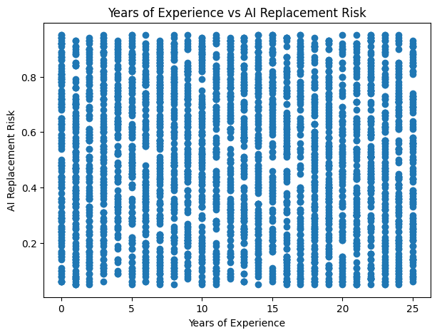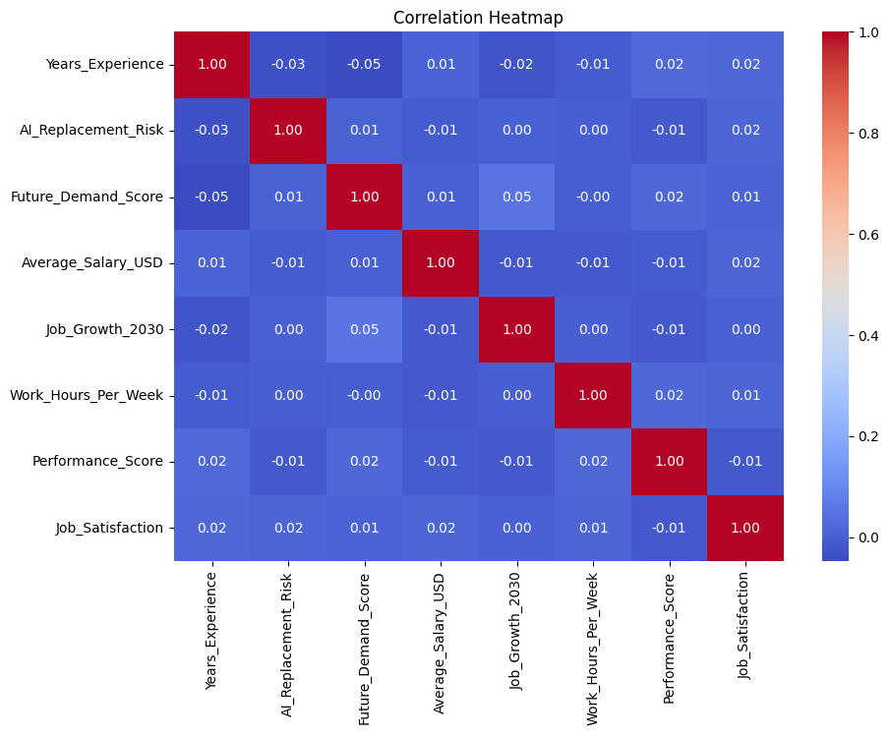

RESULT:

\

